**DEVOPS TRAINING**

DAY 2

Step 1: create repository in github

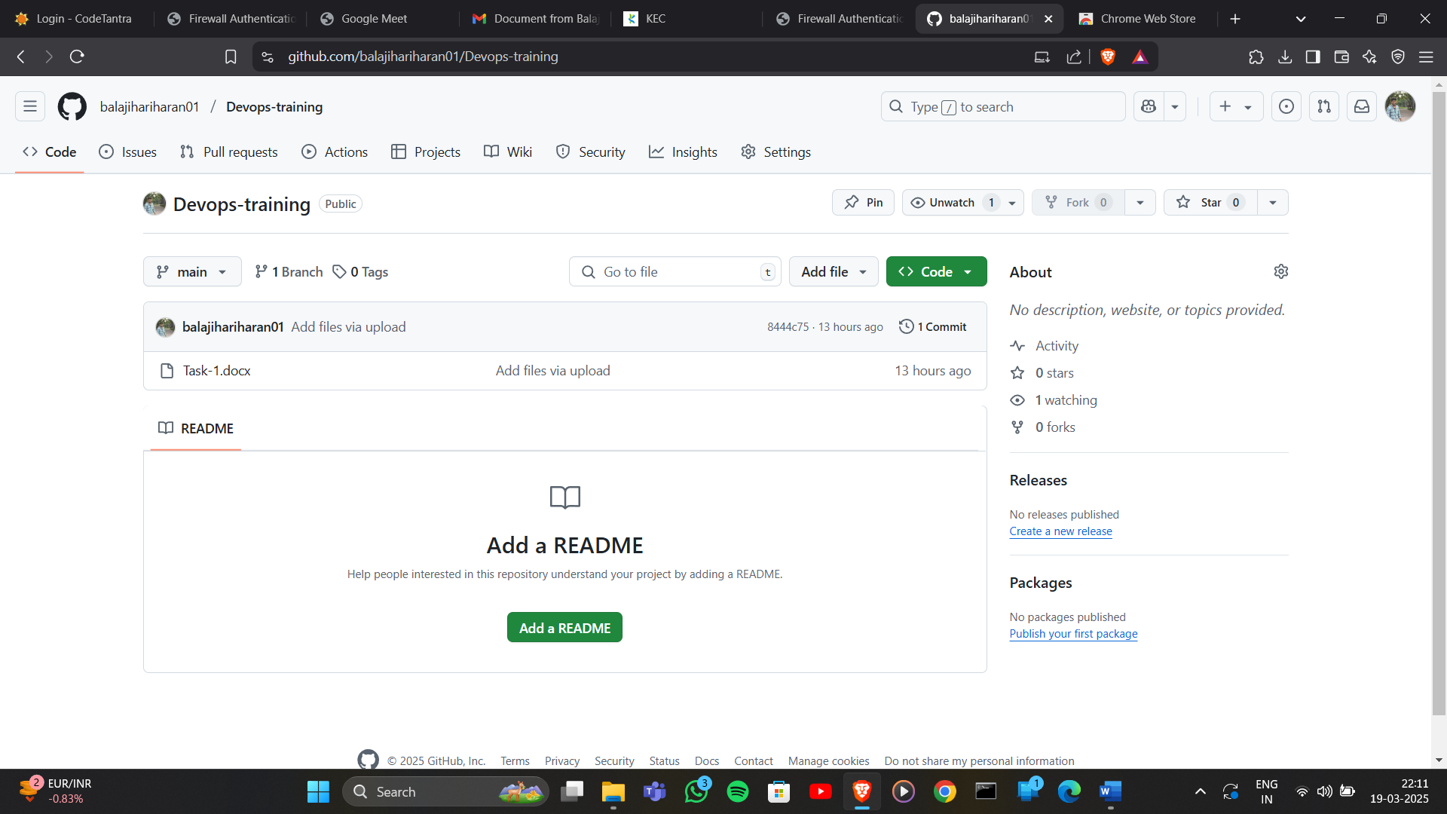

Step 2: go to developer settings

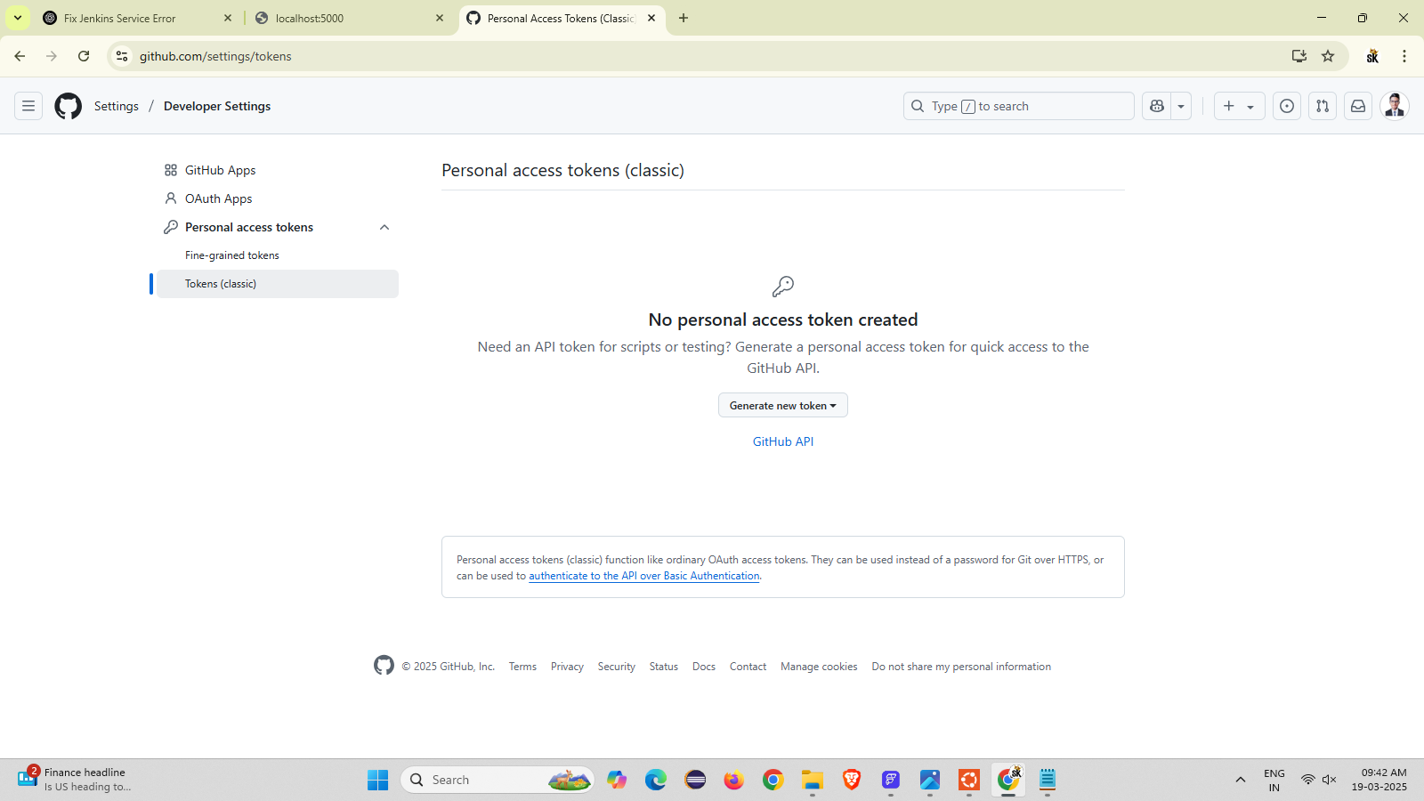

Step 3: generate and copy the token (classic)

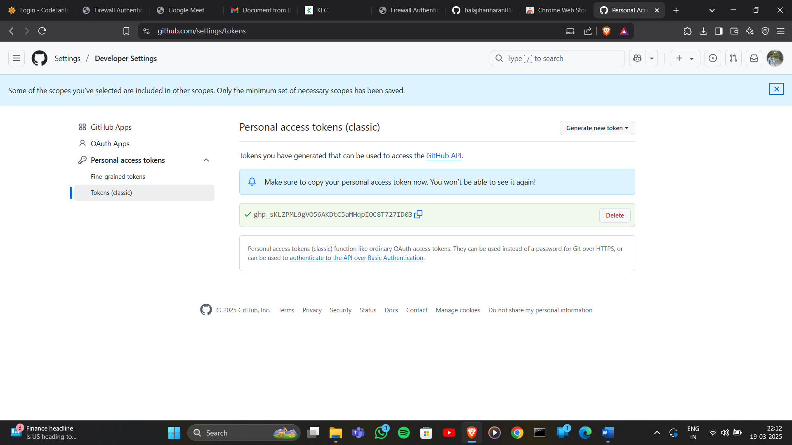

Step 4: open Jenkins and create new item and select pipeline in that go to configuration add github repository url into it

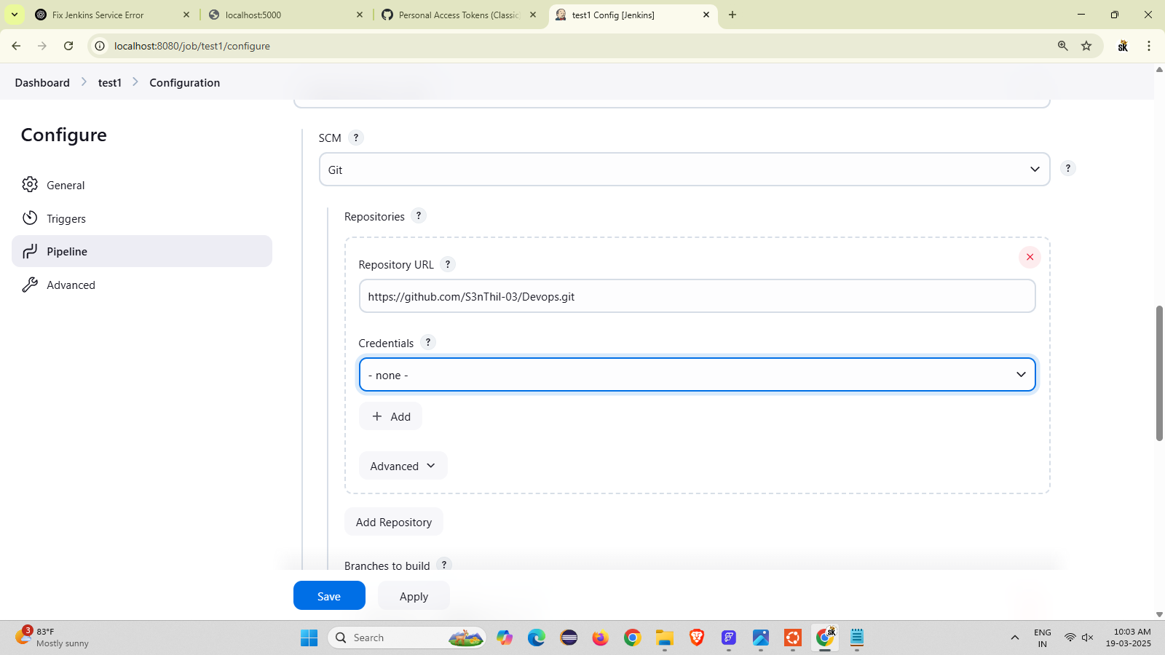

Step 5: in Jenkins configure save it

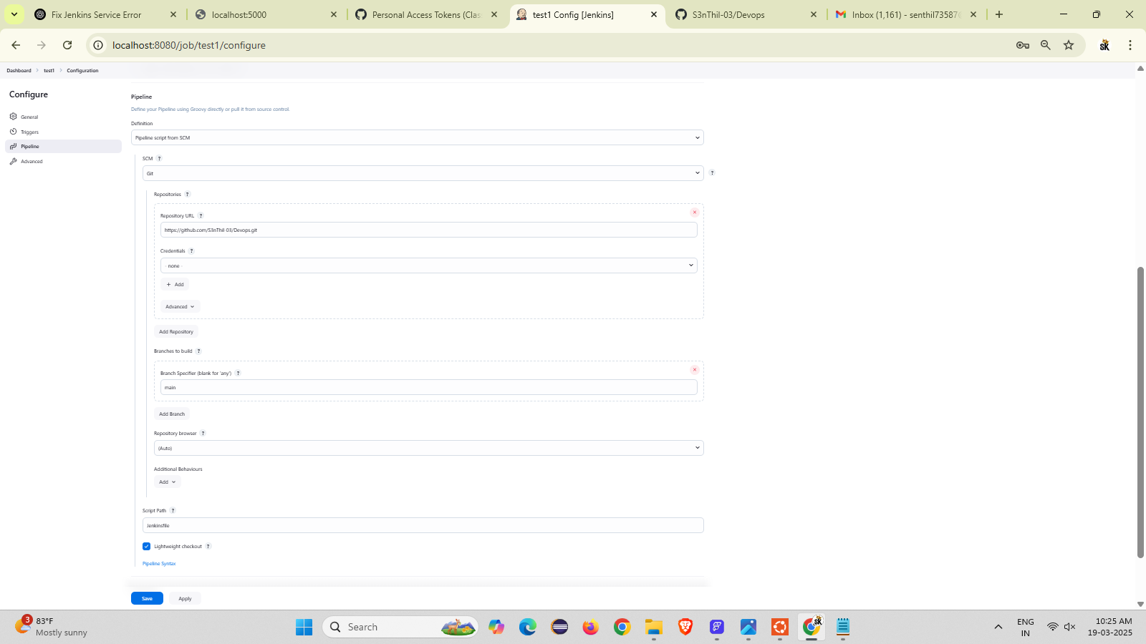

Step 6: verify the status page

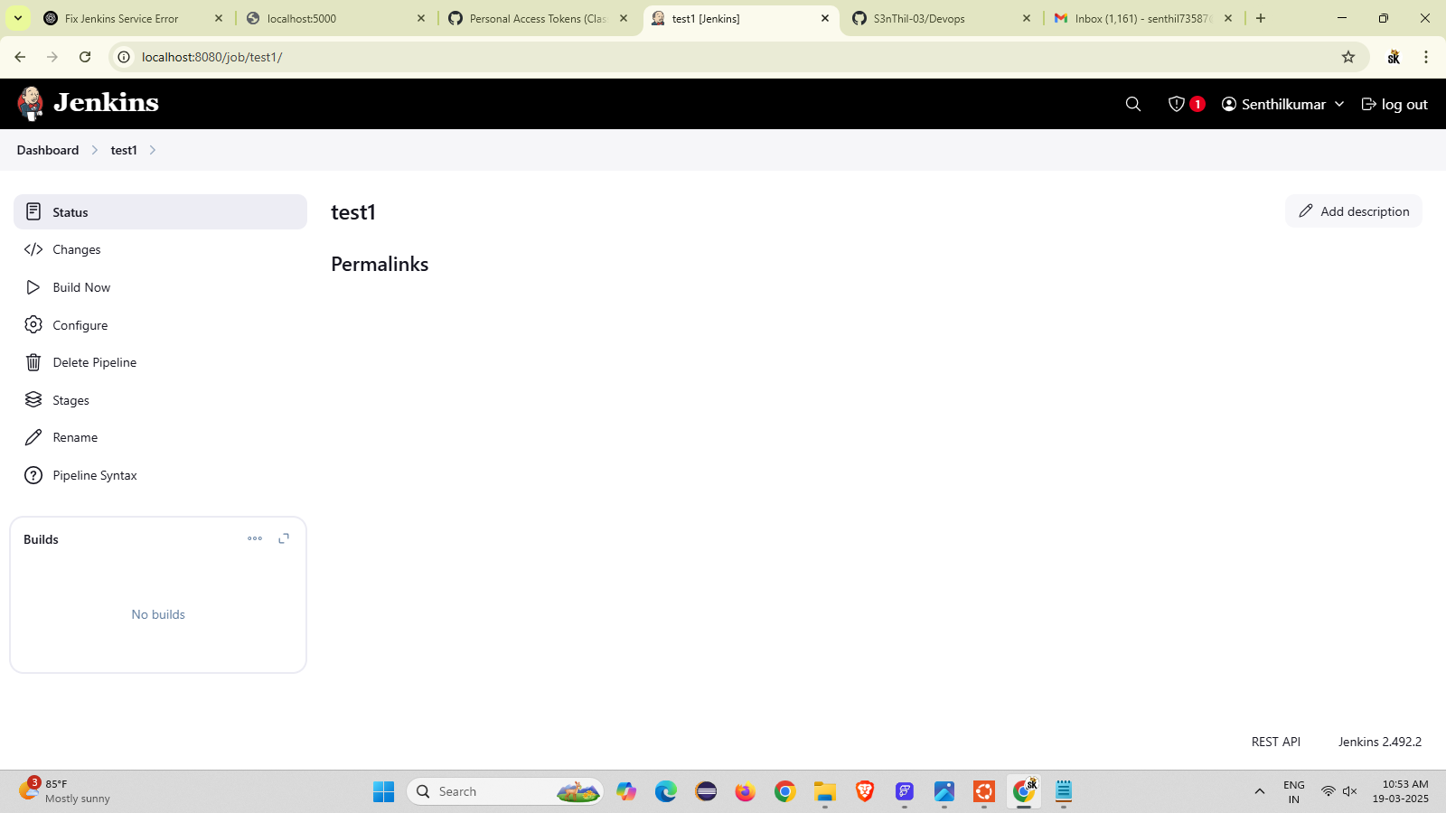

Step 7: clone the git repository

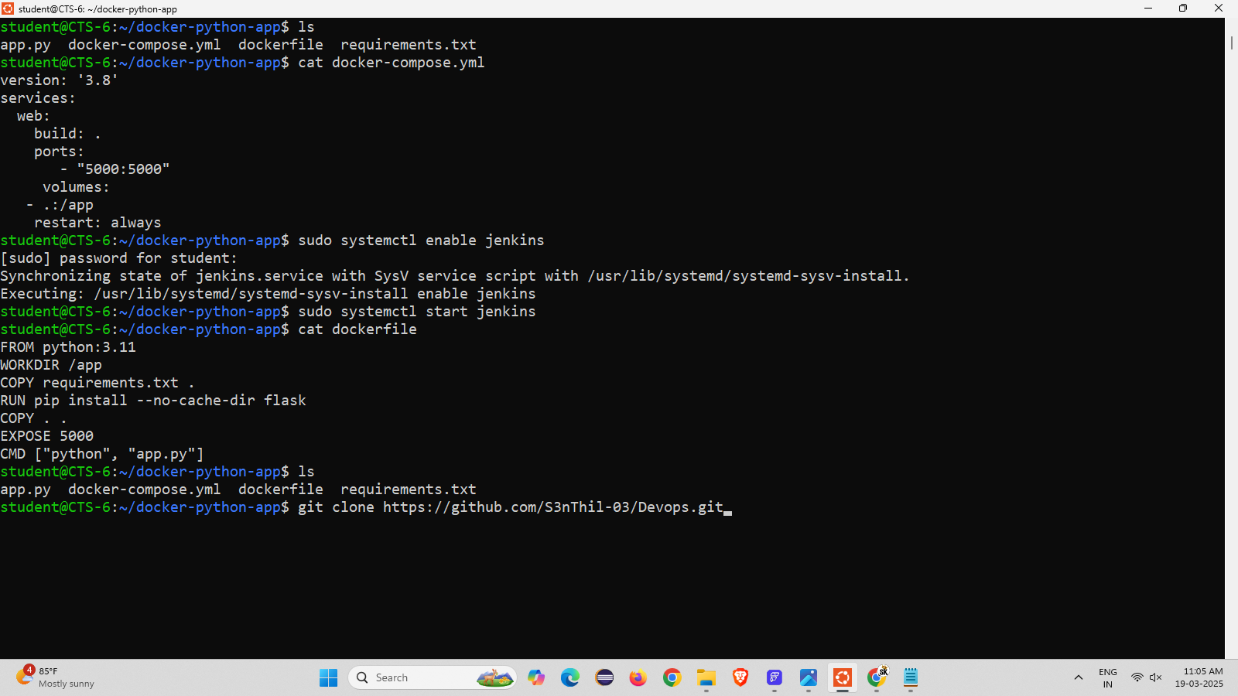

Step 8: using cd add the repository into it

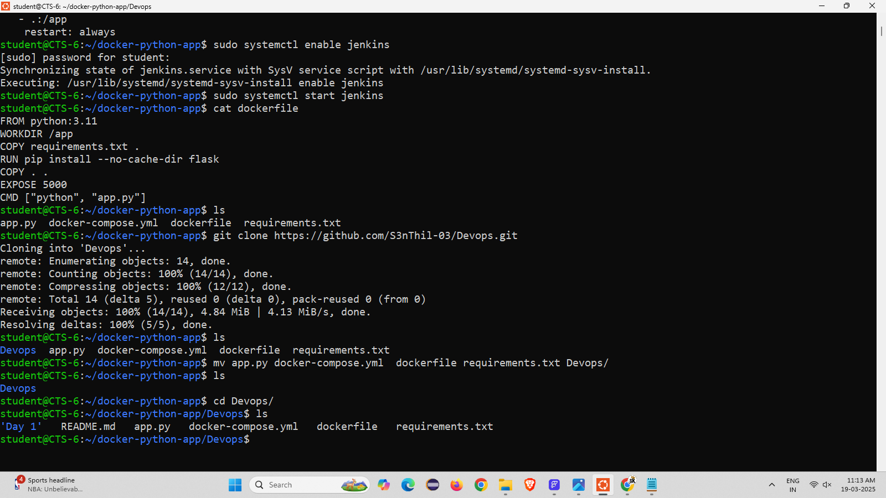

Step 9: using git push command to push all the files into github

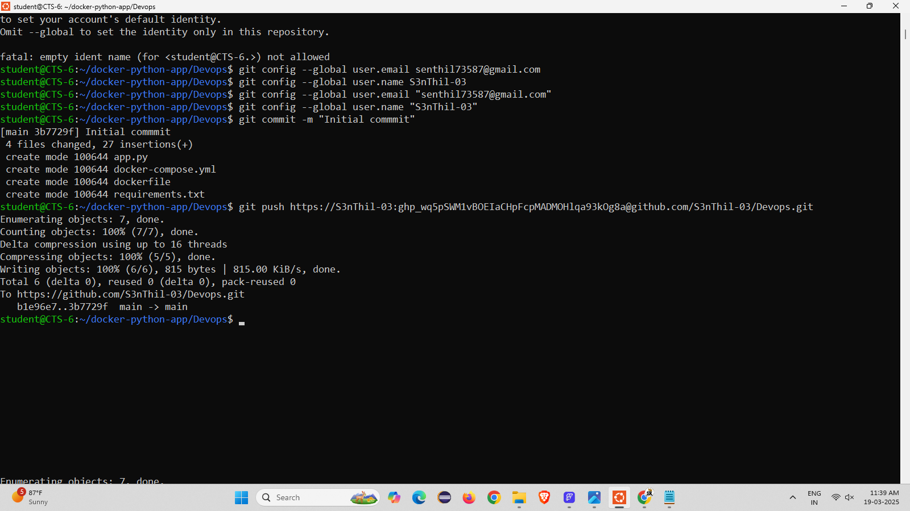

Step 10: check the docker all the files are uploaded in the github repository

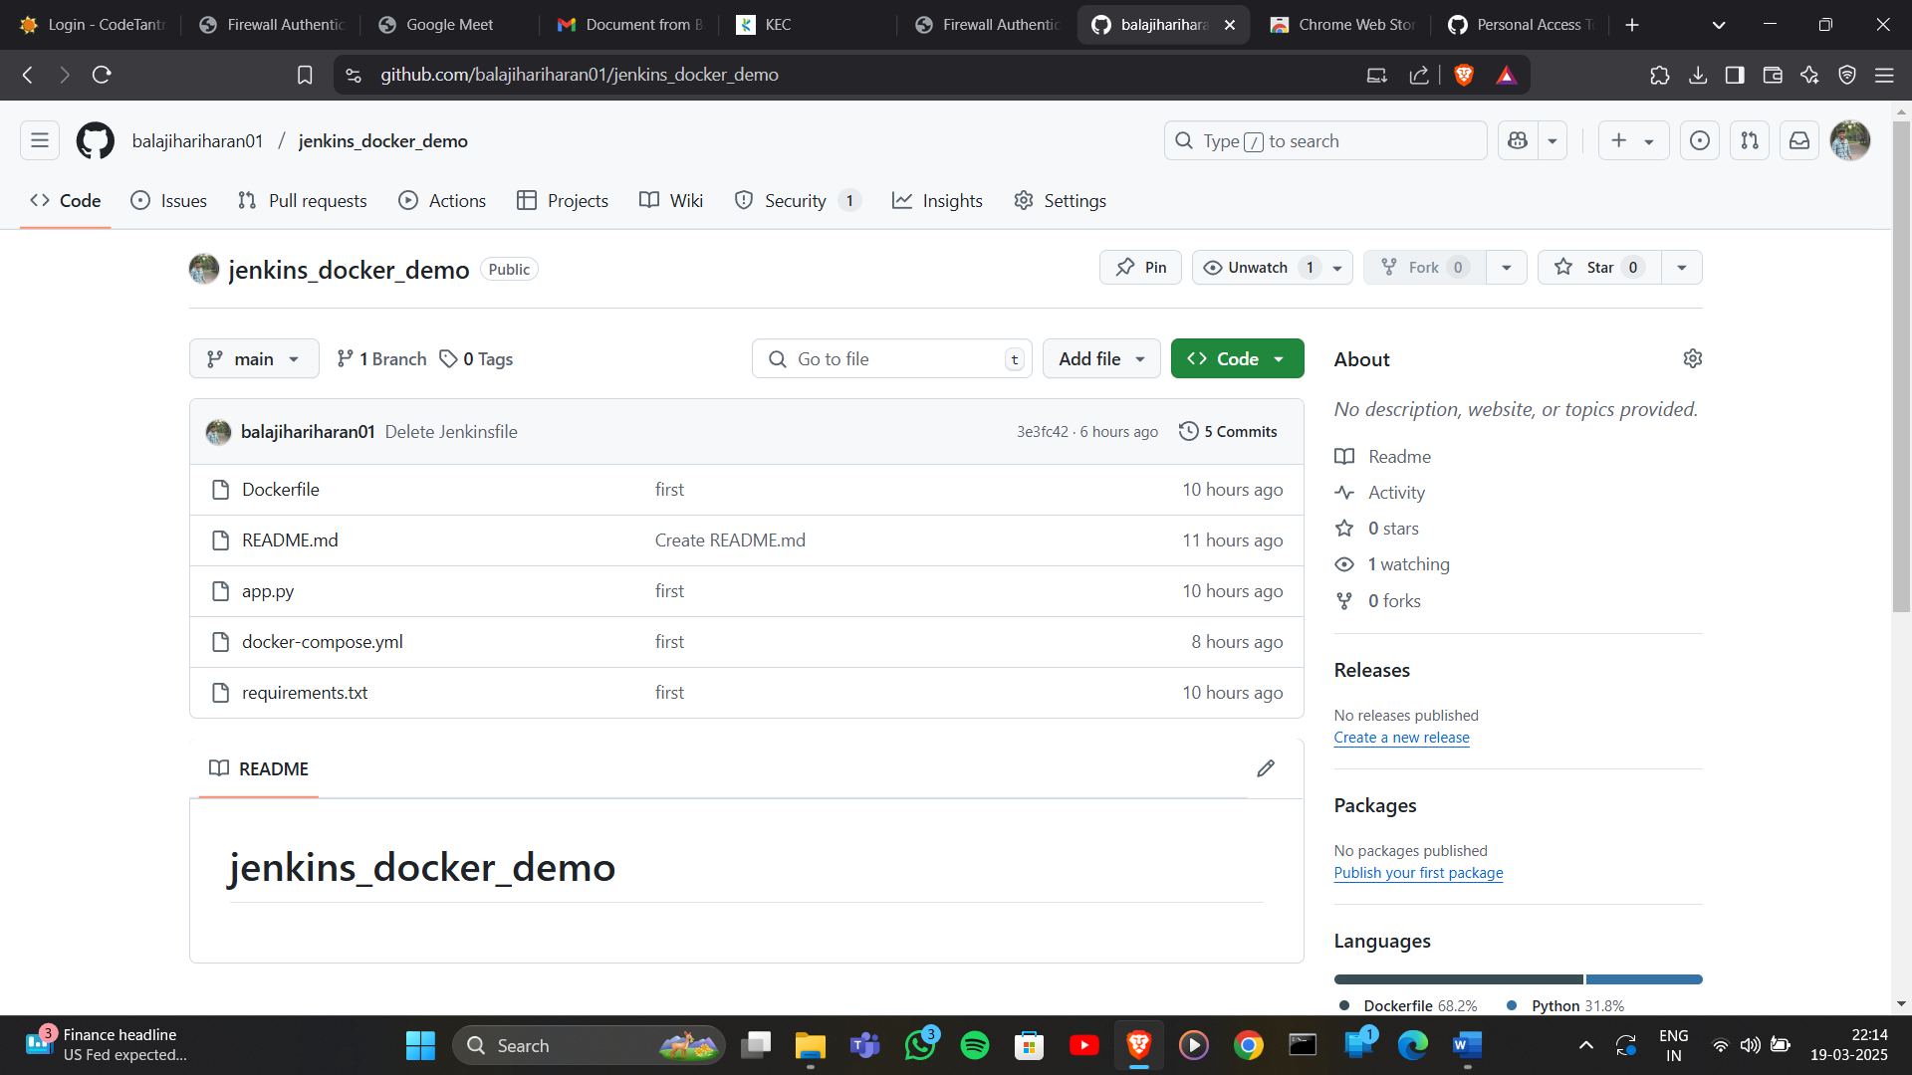

Step 11: go to the docker and login in

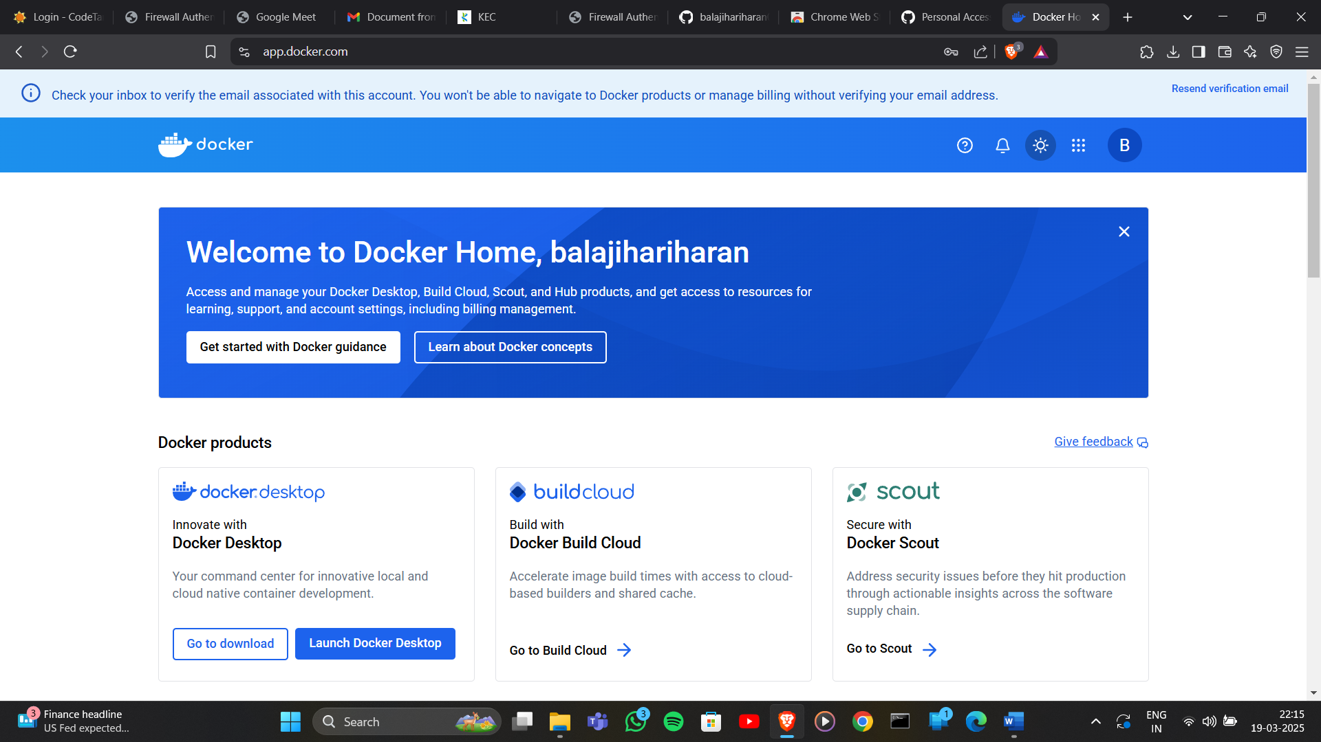

Step 12: in jenkins copy the global credentials and change in the jenkins file

Step 13: commit the jenkinsfile into github

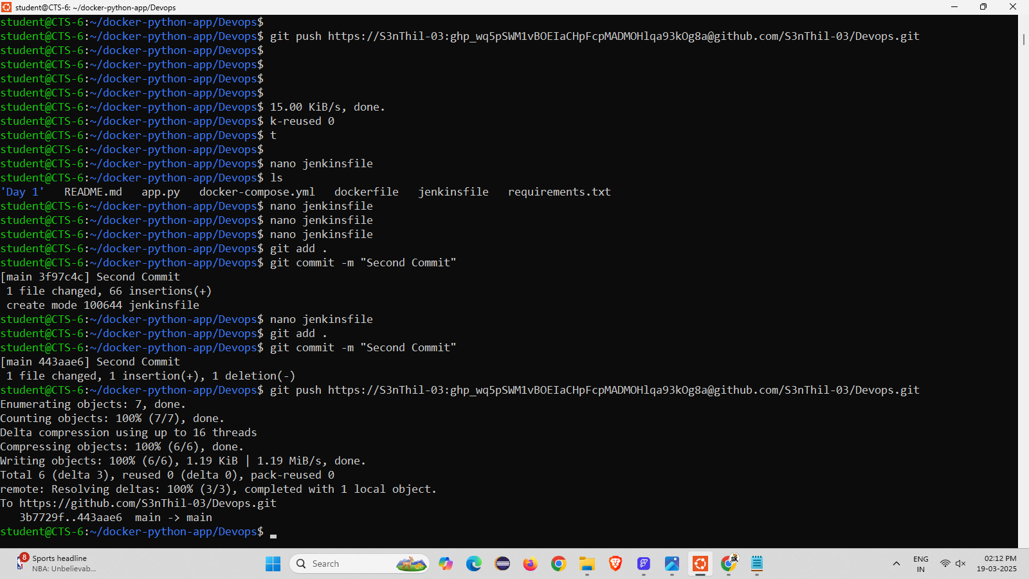

Step 14: verify the jenkins file is pushed in the github

Step 15 : using “sudo usermod –aG docker jenkins” and restart the jenkins

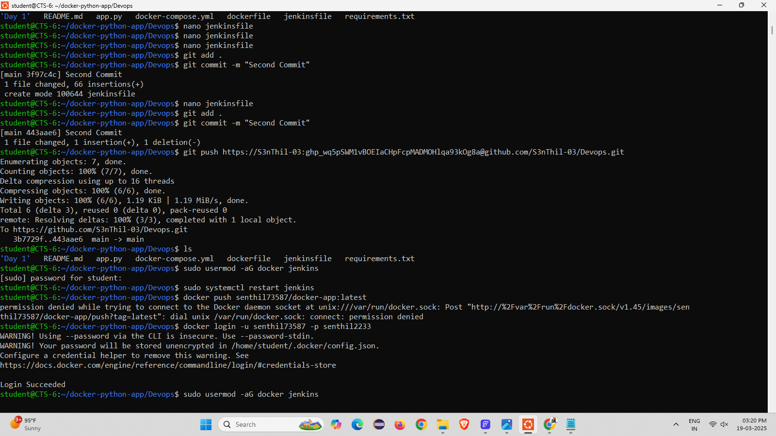

Step 16 : build the item and check the output in console output

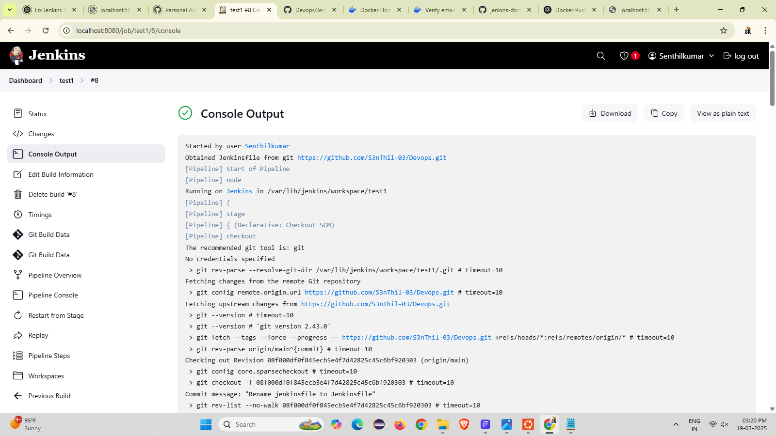

Step 17 : run the localhost:5001

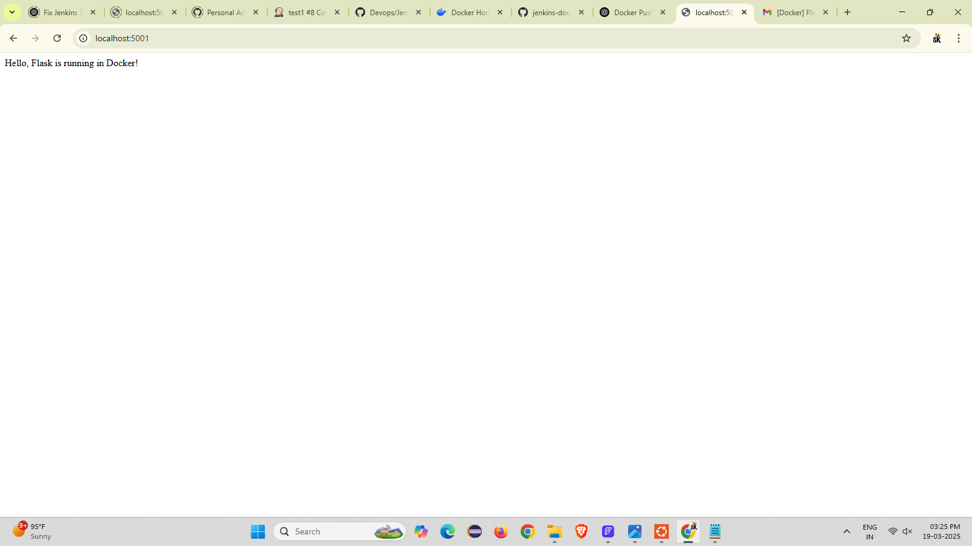

Step 18 : check the image repository in docker